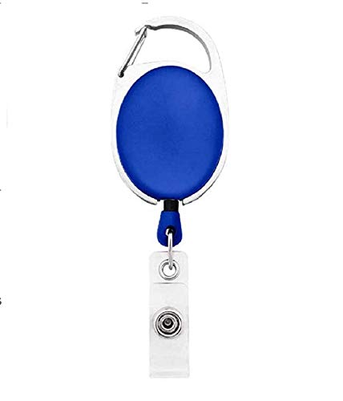

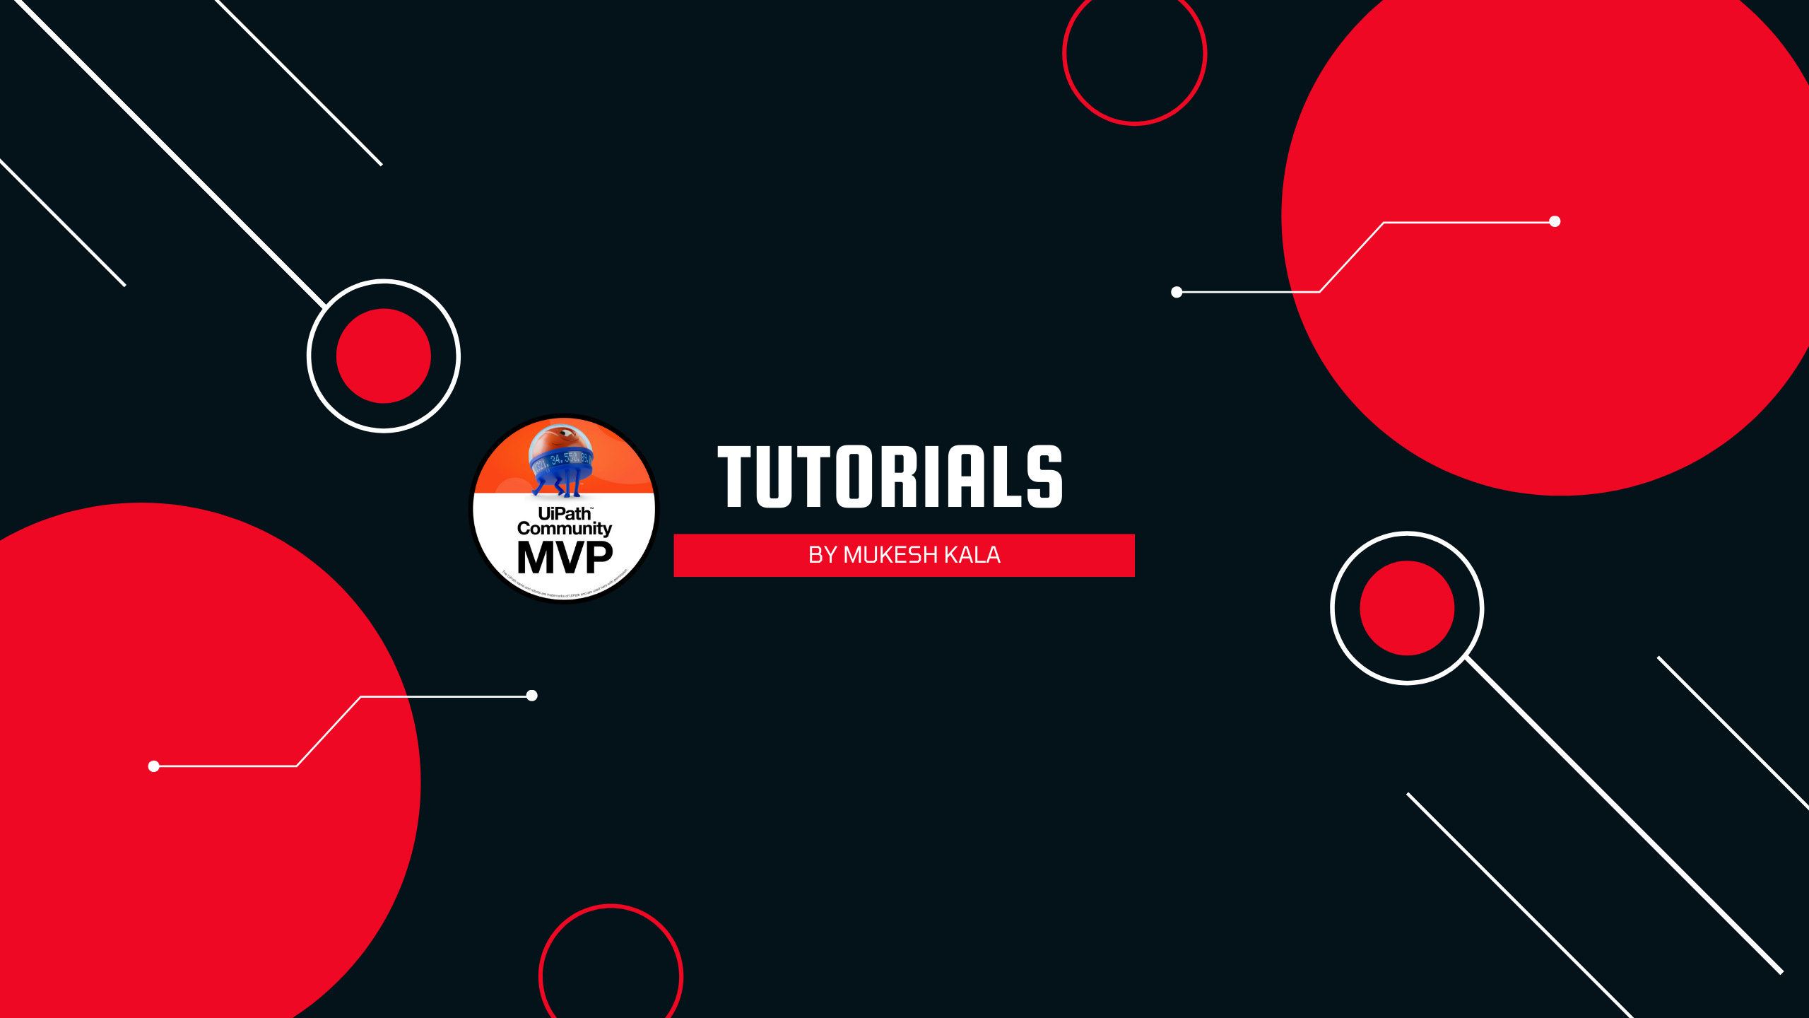

William Middlebrooks | 
Purchase
02/12/2022
A +ve
12345678

Questions / Queries – Drop an email to mailmukeshkala@gmail.com

